Group Project: Scheduling with Gantt Chart
- A brief summary of the project activities identified
The project will most likely follow activities that involve execution, control, and closeout. The following are those that pertain to the execution of the project: verify and validate user requirements, design systems, procure hardware and software, install development system, test the system, install the live system, provide user training, and implement a live version of the system. The next list consists of those for the control of the project: project management, project status meetings, risk management, and updates on project management plan. The last few relate to the closeout of the project: form an audit of the procurement, make a document for lessons learned, update records, gain formal acceptance, and archive documents and files for future reference.

List of Activities:
Initiating: 6 days
- Assign project manager 1 day/ 2 days = 1 day
- Create project 2 days/ 4 days = slack time will be 2 days
- Create project team 3 days
Planning:
- Scope statement
- Identify project idea
- Identify requirements
Executing:
- Design public and private website
- Present design options
- Draft finalized design options
- Develop website
- Review website (review and make necessary changes)
- Finalize website (make sure all changes have been made and requirements met)
- Test
- Implement
- Train
Controlling:
- Project management
- Hold meetings
- Perform quality control
- Risk management
- Evaluate/Update cost estimates
- Respond to changes
- Update project management plan
Closing:
- Project management plan
- Confirm work is done
- Complete final performance reporting
- Discuss and document lessons learned
- Project formal acceptance

- A brief summary of the project activities and WBS you identified.
PPI Customer Support System Project will consist of the 5 groups. Under the Initiating column will include the Assigned Project Manager and Create Project Name. Next is the Planning group which includes the Scope Statement, Management Plan, Communications, Create Schedule, and Build Team. Also, there is the Executing group that oversees the Implementation Plan, System Design, and Testing Phase. The Controlling/Monitoring group is responsible for all areas related to QA/QC, Budget, Process Reports, Change Reports, and the Contingence Management Plan. Finally, is the Closing group that manages the Records, Project Completion, and Document Lesson Learned information associated with the project.

PPI CSS Project
Initiating
- Assign Project Manager
- Create Project Name
Planning
- Scope Statement
- Management Plan
- Communications
- Create Schedule
- Build Team
Executing
- Implementation Plan
- System Design
- Testing Phase
Controlling/Monitoring
- QA/QC
- Budget
- Progress Reports
- Change Requests
- Contingence Management Plan
Closing
- Records
- Project Completion
- Document Lesson Learned
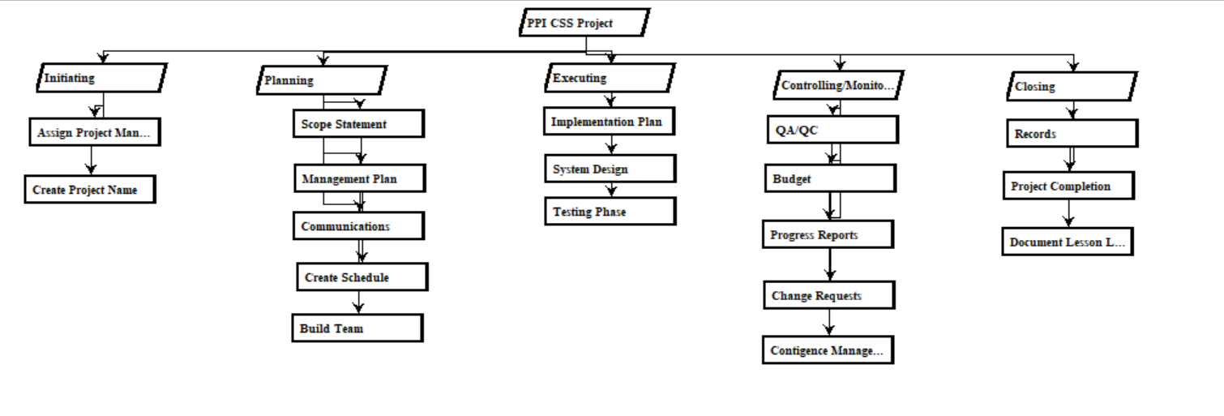
- A 4-5 page report that includes your group’s WBS and Gantt chart as well as your answers to the questions listed above.
The items that I believe that is safe is the implementation plan. It has the safest of the QA/QC process to ensure the system is running before it begins.
The critical path items are the system design, testing phase, QA/QC. They are the critical path items because both system design and testing phase require QA/QC approval to proceed to ensure that the system will properly run without any unsecured areas of possible vulnerabilities that could leave customer’s information unprotected.
The items that would suffer are the system design and testing phase. If any of these two items have any delays, it will cause the timeline to stretch, therefore causing the budget to increase. Also, it would push back the implementation plan.
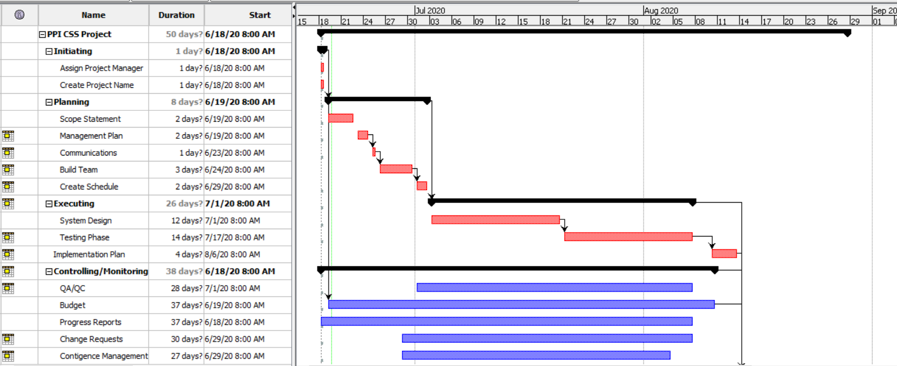
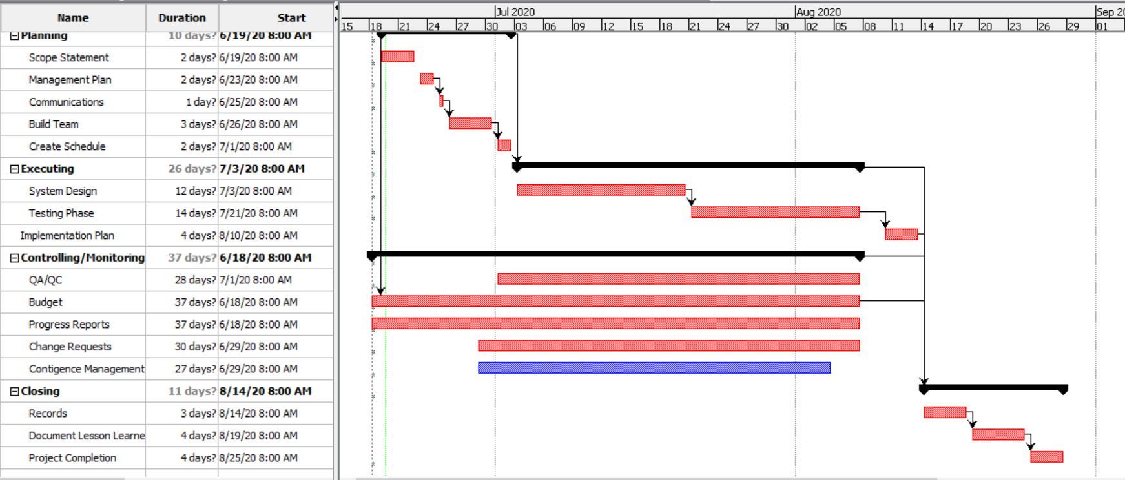

Reference:
Schwalbe, Kathy (2016) Information Technology Project Management (8e Addition). Boston: Cengage Learning.
Wroblewski, M.T. (May 2019) Major Activities in Project Management Phases.
Retrieved from https://smallbusiness.chron.com/major-activities-project-management-phases-35964.html

